Window Builder in Java/Eclipse2

Finally to Link to Application:

**public** **class** Counter {

**private** **int** value;

**public** Counter(**int** v){value=v;}

**public** **int** readValue(){**return** value;}

**public** **void** step(){value++;}

}

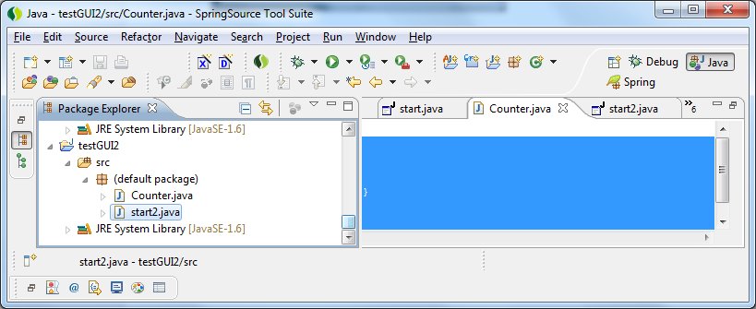

Put Counter in same Project

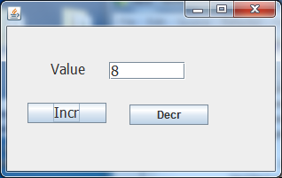

textField

Then Need to modify Code as follows:

**public** **class** start2 {

**private** JFrame frame;

**private** JTextField textField;

**Counter c = new Counter(6);**

/**

* Launch the application.

*/

**public** **static** **void** main(String[] args) {

:

}

/**

* Create the application.

*/

**public start2() {**

**initialize();**

**myRefresh();**

**}**

**public void myRefresh(){**

**textField.setText(""+c.readValue());**

**}**

/**

* Initialize the contents of the frame.

*/

**private** **void** initialize() {

frame = **new** JFrame();

:

textField.setColumns(10);

JButton btnIncr = **new** JButton("Incr");

**btnIncr.addActionListener(new ActionListener() {**

**public void actionPerformed(ActionEvent e) {**

**c.step();**

**myRefresh();**

**}**

**});**

btnIncr.setFont(**new** Font("Tahoma", Font.*PLAIN*, 16));

:

}

}

Dialogs

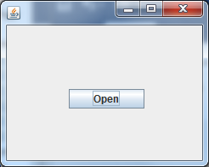 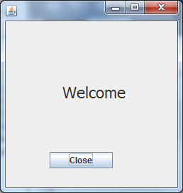

**public** StartWindow() {

initialize();

}

**private** **void** initialize() {

frame = **new** JFrame();

frame.setBounds(100, 100, 450, 300);

frame.setDefaultCloseOperation(JFrame.*EXIT_ON_CLOSE*);

frame.getContentPane().setLayout(**null**);

JButton btnOpen = **new** JButton("Open");

btnOpen.addActionListener(**new** ActionListener() {

**public** **void** actionPerformed(ActionEvent arg0) {

**new** test1();

}

});

btnOpen.setBounds(73, 75, 89, 23);

frame.getContentPane().add(btnOpen);

}

JButton btnClose = **new** JButton("Close");

btnClose.addActionListener(**new** ActionListener() {

**public** **void** actionPerformed(ActionEvent arg0) {

frame.setVisible(**false**);

}

});

btnClose.setBounds(62, 185, 89, 23);

frame.getContentPane().add(btnClose);

frame.setVisible(**true**);

}